# Performance descriptors

**Task 1**

**Task achievement**   
This assesses how appropriately, accurately and relevantly the response fulfils the requirements set out in the task, using the minimum of 150 words. Academic Writing Task 1 is a writing task which has a defined input and a largely predictable output. It is basically an information-transfer task that relates narrowly to the factual content of an input diagram and not to speculative explanations that lie outside the given data.

**Coherence and cohesion**   
This concerns overall clarity and fluency: how the response organizes and links information, ideas and language. Coherence refers to the linking of ideas through logical sequencing. Cohesion refers to the varied and appropriate use of cohesive devices (for example, logical connectors, pronouns and conjunctions) to assist in making the conceptual and referential relationships between and within sentences clear.

**Lexical resource**   
This refers to the range of vocabulary used and its accuracy and appropriacy in terms of the specific task.

**Grammatical range and accuracy**   
This refers to the range and accurate use of grammar as manifested in their sentence writing.

**Task 2**

**Task response**In both IELTS Academic and IELTS General Training versions, Task 2 requires test takers to formulate and develop a position in relation to a given prompt in the form of a question or statement. Ideas should be supported by evidence, and examples may be drawn from the test takers’ own experience. Responses must be at least 250 words in length. Scripts under the required minimum word limit will be penalized.

**Coherence and cohesion**   
This assesses the overall clarity and fluency of the message: how the response organizes and links information, ideas and language. Coherence refers to the linking of ideas through logical sequencing. Cohesion refers to the varied and appropriate use of cohesive devices (for example, logical connectors, pronouns and conjunctions) to assist in making the conceptual and referential relationships between and within sentences clear.

**Lexical resource**This criterion refers to the range of vocabulary used and its accuracy and appropriacy in terms of the specific task.

**Grammatical range and accuracy**   
This assesses the range and accurate use of grammar, as manifested in their test takers’ writing at sentence level.

# ESSAY 1

### TASK 1

**You should spend about 20 minutes on this task.**

**The graph below presents the car sales of three brands in certain European countries in 2018.**

**Summarise the information by selecting and report in the main features, and make comparisons where relevant.**

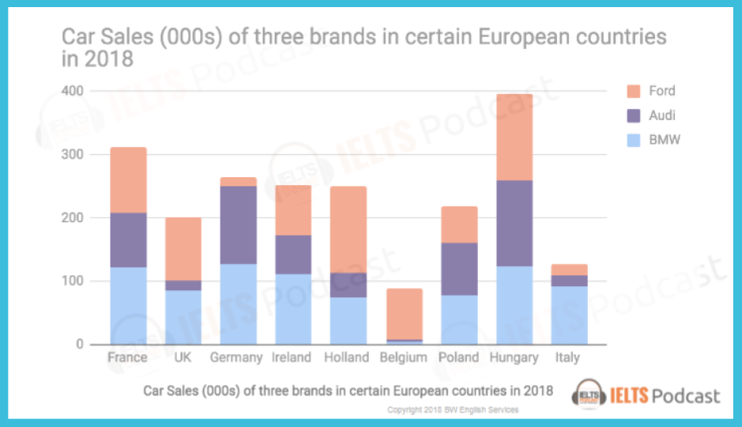

The given chart compares the number of cars sold from three major brands in nine European countries in the year 2018.

Roughly speaking, the cars of three brands were sold the most in Hungary and the least in Belgium. While BMW was most popular brand among four countries, France, Ireland, Poland and Italy, Ford recorded the highest sales in UK and Holland. In the most of the nine countries, Audi sold the least number of cars except Germany and Poland.

Ford succeeded in selling cars in Holland and Hungary the most, with the approximate number of 140s cars, and relatively failed in Germany with less than 30s cars. Audi had the best sales result in Germany and Hungary which reached more than 100s cars. BMW recorded the highest sales in France, Germany and Hungary with more than 100s cars while it recorded the lowest sales in Belgium less than 20s cars.

**FEEDBACK**

1. Very short. It’s exact 150words.
2. Ideal structure:

* Introduction
* Overview: she would say that in Hungary cars were sold the most and in overall countries, BMW sold the most. -> Normally starts from ‘Overall’, ‘Clearly’.
* Paragraph 3: She would start with countries. “Grouping” is very important in IELTS. She would group top 2 (Hungary, France which are more than 300,000), bottom 2 (Belgium, Italy, which are less than 200,000) and in the middle which are between 200,000 to 300,000, mentioning with numbers. In this way, you can talk all about countries.
* Paragraph 4: Grouping with car companies. You can talk about then highest & lowest countries by companies, but you need to mention at least one time of all countries and companies. Use all infos around the graph.

1. She couldn’t visualize with this writing. You need to imagine that you’re giving this info to someone who doesn’t have this in front of them.

**AFTER CORRECTION**

The given chart compares the number of cars sold from three major brands in nine European countries in the year 2018.

Overall, the cars of three brands were sold the most in Hungary and the least in Belgium. All three brands of car sold the similar number of cars in Hungary without a significant gap, whereas Ford occupied a majority of sales than the others in Belgium.

In all nine countries, the companies surpassed more than 300,000 sales record in only Hungary and France, and they could not reach 200,000 sales in Belgium and Italy. The rest of the countries, UK, Germany, Ireland, Holland and Poland, the sales recorded between 200,000 and 300,000.

Ford yielded best result in Hungary and Holland while worst record in Italy and Germany. Audi sold most in Hungary and Germany whereas least in Belgium where they barely recorded. Finally BMW recorded great result in France, Germany and Hungary with more than 100,000 cars, but could not record significant result in Belgium.

# ESSAY 2

### TASK 2

**These days, problems with pollution are becoming worse, particularly in large cities. What are the reasons for this and how can this be solved?**

**Give reasons for your answer and include any relevant examples from your own knowledge or experience.**

The global society is suffering from pollution more than ever before, and it is deteriorating, especially in the large cities. Vast amounts of waste from consumers and industries are threatening our lives and this provokes natural hazards.

One reason why pollution is much more severe in large cities than small cities comes from the characteristic of urban ambient. As the city becomes bigger than in the past in terms of size of population and business, it subsequently creats some hectic places where adequate civil management does not work well. Most of these places are busy in the day time with people, and also serves as a home for the homeless people. The city where I currently live, Chicago, has various busy places usually near downtown, and I see a big amount of scattered waste on the streets every day. The more people who come to these places, the more waste is abandoned without any regulation.

Another reason behind pollution is the tendency of all business by which they try as much as they can in order to safeguard their interest. If any kind of city regulation on waste took place, it would bring a certain negative impact on their business. As long as the existing business model and the product lifecycle are not changed, it is hardly expected that businesses would be willing to favor the regulations, since its main objective is to produce and pack a commodity with the least cost and get the biggest interest.

In order to alleviate the pollution in large cities, there should be a structural transition to a new sustainable business model, and great collaboration with city authority. It can be started from the basement, by advocating the value of conserving environment and raise the severity of the issue.

**FEEDBACK**

1. Condense paragraph 2 and 3 into 1 about bad maintenance, homeless, business etc. And make second paragraph with solutions.
2. Putting solutions into conclusion is not good, and very under developed. Need more analysis on solution in a solid one paragraph.
3. Ideal structure:

* Introduction: acknowledge the severity of problem and solution.
* Body 1: Suggest reasons.
* Body 2: In-depth solutions.
* Conclusion

**AFTER CORRECTION**

The global society is suffering from pollution more than ever before, and the consequences of pollution is deteriorating, especially in the large cities. Vast amounts of waste from consumers and industries are threatening our lives and this provokes natural hazards. In order to alleviate the pollution in large cities, there should be a structural transition to a new sustainable business model, and great collaboration with city authority.

One main reason of severity of pollution in large cities is that the current level of civil management from city authority cannot keep up with the speed of city’s expansion. The city where I currently live, Chicago, has various busy places usually near downtown, and I see a big amount of scattered waste on the streets every day. The more people who come to these places, the more waste is abandoned without any regulation. Another reason behind pollution is the tendency of all business by which they try as much as they can in order to safeguard their interest. If any kind of city regulation on waste from product manufacturing and packaging took place, it would bring a certain negative impact on business.

As a solution, reinforcement for well-organized civil management from city authority is needed, which can be led by distributing adequate number of labor force and equipment on each district as well as a structural reform on current business model. As long as the existing business model and the product lifecycle are not changed, it is hardly expected that businesses would be willing to favor the regulations, since main objective of business is to produce and pack a commodity with the least cost and get the biggest interest.

Therefore, the endeavor from both public and private sector is needed to result in a tangible impact to mitigate pollution in large cities, and a robust cooperation would be the key element of this solution.

## ESSAY 3

### **TASK 1**

**You should spend about 20 minutes on this task.**

**The graph below presents the movie preferences of young adults (worldwide).**

**Summarise the information by selecting and report in the main features, and make comparisons where relevant.**

**Write at least 150 words.**  
 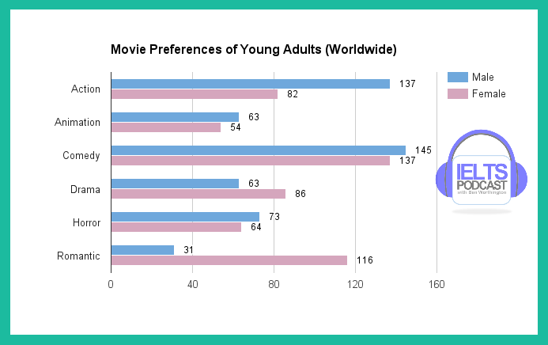

The given graph compares the movie preferences of young adults in the world among six different genres of movie.

Overall, comedy is the most preferred movie for both male and female young adults which 282 adults in total chose, while animation is the least preferred movie with the low number of 117 adults.

Among young male adults, action and comedy movies are the most preferred which each have more than 130 respondents, whereas romantic movies are the least preferred with less than 40 respondents. In the young female group, however, only comedy surpassed 120 respondents which is followed by romantic movie. There is no movie chosen by less than 40 females, yet animation was the least preferred.

Romantic movie recorded the biggest gap between gender of 85 respondents among six genres, and comedy movie recorded the smallest gap of 8.

FEEDBACK

1. You left out many infors in graphs. I cannot see any mention on horror and drama. Cover all general key features is one of the scoring points. (Please refer to IETLS score boundary chart.) You absolutely mention male and female and all categories even if it’s only one time and only name. You could even mention merely their names in introduction.
2. Please write as if you’re explaining to a person who doesn’t have the graph in front of him. Even if you only mention the names of categories, you’re safe. They might think that you left out some details, but they won’t give a very low score.
3. The organization of the writing is little awkward. Some ways of organizing it is more successful than others.
4. She would start off with the men and first with comedy and action. Then she would take the next three genres because all of three has similar amounts of respondents. You can say that horror is half of comedy. For example, talk about action and comedy together and then say that the third most popular movie genre among men was approximately half of the first two which is horror at 73. This was followed by animation and drama which each had 63 respondents and half of those people responded that they prefer romantic movie at only 31. And then you can write the similar paragraph for women. As with men, the most women preferred comedy at 137 followed closely by romantic films at 116. And group drama and action together, and one quick sentence about animation and horror.

**AFTER CORRECTION**

The given graph compares the movie preferences of young adults in the world among six different genres of movie.

Overall, comedy is the most preferred movie for both male and female young adults which 282 adults in total chose, while animation is the least preferred movie with the low number of 117 adults.

Among young male adults, comedy and action movies are mostly chosen as their preferred movie, and horror movies followed next with half of the respondents from comedy. Both animation and drama follow next with low number of respondents of 63, and the least preferred movie was 31 which is half of animation and drama.

As with men, the most preferred movie for female group was comedy at 137 followed closely by romantic films at 116. Drama and action movies were the second and third most preferred at 86 and 82 each, and horror and animation movies were least preferred at 64 and 54 each.

## ESSAY 4

### TASK 2

**These days more and more people are travelling domestically or internationally.  There are clearly many benefits to it but there are some who argue that it has also some drawbacks. Discuss the advantages and disadvantages of travelling?**

**Give reasons for your answer and include any relevant examples from your own knowledge or experience.**

As globalization is spread to the whole world and technology is advanced, international and transcontinental travels have become far easier than ever before. While most people say that this change is beneficial, some are worried about its backlash.

The biggest benefit of travel is that by traveling to different countries in the world, people can learn each country's local culture and landscape firsthand rather than learning by images and texts. In my case, I traveled Central and South America for a few months in 2017 and I experienced invaluable lessons that I could never learn from the media and class. It helped me a lot to broaden my insight on South America because the continent was such an exotic location for me before I traveled. Especially regarding the distance between South America and my country, South Korea, I could never imagine traveling across the continents before globalization and advanced technology.

On the other hand, a surge of international travel has brought urban problems such as pollution and crime. Especially in tourist countries where millions of tourists come every year, robbery of international tourists has become very prevalent and the countries have become being unable to control vast amounts of waste. The local residents who used to live in touristic places tend to leave their cities because of the massive amounts of tourists visiting their hometown and noise that tourists make. The national and city authorities cannot control these drawbacks (disadvantages, negative aspects etc) effectively because tourism has become very important for the country's economic profit.

There are two flipped sides when it comes to domestic and international travels, and it is becoming controversial whether these travels benefit the people and the world as a whole. Yet, being a responsible traveler could contribute to alleviating the disadvantage of travels at an individual level.

FEEDBACK

1. She liked a lot what I wrote in terms of the content. Nicely developed, thoughtful essay, interesting things to say. Some little errors in terms of grammar, word choice, some awkwardness of expression. But in terms of task achievement, she’s happy with it.
2. She thinks the leak spot for me is task 1 primarily because I missed some key information. Task 1 is low in the content. It’s low developed partially because I didn’t use all categories. Also, it’s better to do grouping these information more appropriately.

# ESSAY 5

### TASK 1

**You should spend about 20 minutes on this task.**

**The flowchart below presents the steps in producing tea.**

**Summarise the information by selecting and report in the main features, and make comparisons where relevant.**

**Write at least 150 words.**

**FLOWCHART HERE:** [**https://www.ieltspodcast.com/fresh-tea-leaves-flowchart/**](https://www.ieltspodcast.com/fresh-tea-leaves-flowchart/)

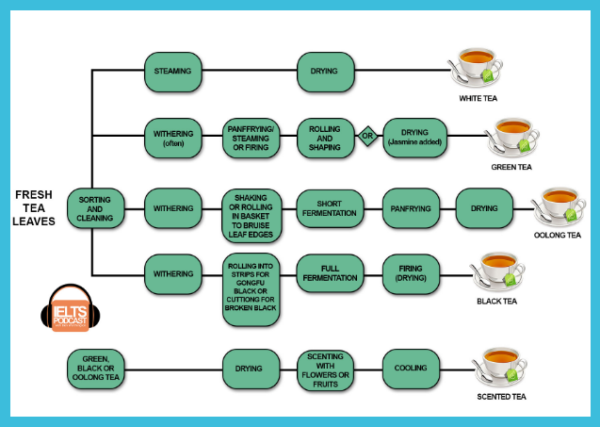

The given flowchart shows the procedures of making various types of tea.

Overall, the simplest tea to make is white tea which has only three steps to follow, sorting and cleaning, steaming and drying, and the tea that has the most complicated process is oolong tea which has twice as many steps as white tea.

White, green, oolong and black tea start off the process by sorting and cleaning the fresh tea leaves whereas scented tea directly begins with drying. After sorting and cleaning the tea leaves, withering process follows when you make green, oolong, and black tea. While oolong and black tea start with rolling first then panfrying or firing after withering, green tea has the opposite order which is to panfry first and roll after. Especially in the case of oolong and black tea, they have to be fermented shortly and fully each after rolling.

The last step for all teas with the exception of scented tea is drying, but firing works as drying as well for black tea. In the case of scented tea, it is scented with flowers or fruits and then cooled down as the last step. (197 words)

**FEEDBACK**

1. Grammars and vocab were well controlled.
2. Organization of your idea: your overview is too detailed (?)… She would start with white is the simplest, oolong is the most complexed, and scented tea is made out of those three teas. And then start with first step of four tea, and then white tea has only two steps. The three remaining tea, green, oolong black tea share the same second step, withering. While oolong tea and black tea it always happens, for green tea, it is merely often. A common step to green, oolong and black tea is rolling. However, there are some differences among different teas. Green tea is first, steam frying steamed or fired and then rolled and shaped. Bla Bla… And then scented tea can be the last paragraph.

# ESSAY 6

### **TASK 2**

**Local governments are pushing companies to move from large cities to regional locations.**

**What are the benefits and drawbacks of this?**

**Give reasons for your answer and include any relevant examples from your own knowledge or experience.**

Withdrawal of companies from large cities has been one of the consequences of an ever-expanding urban population. This has brought some benefits to cities such as leveraged efficiency of land usage but drawbacks such as decreased accessibility to companies for employees and clients at the same time.

For local government, pushing companies to move from large cities to suburbs or regional locations could be one of the solutions to alleviate congestion in the city. As cities have become larger, all facilities including companies have gathered to large cities for better access to sales and employment and this movement has brought enormous effect to society in terms of the rise of living expense, traffic congestion, and income disparity. By letting companies distributed into various regions, these urban issues could be mitigated.

However, the withdrawal of companies also involves some critical drawbacks, since each company has a different and complicated business ecosystem. In many cases, the company’s sales and employment strategies are affected a lot by its location. For instance, there was an incident where my country’s government, South Korea, pushed many national corporations to move from the capital city of Seoul to another province which takes three hours to arrive. Vast amounts of people who used to work in those corporations either had to quit their jobs or move to another province to keep working there. Besides, the problem of congestion and gentrification in Seoul was not completely solved by merely moving corporations back to regional locations.

There have been continuous discussions on solving urban problems including relocating the companies to suburbs and rural areas, and this would be our ever-ending task that we need to confront. Yet, more precise considerations from views of different facets are needed to tackle these issues wisely. (288 words)

**AFTER CORRECTION**

Withdrawal of companies from large cities has been one of the consequences of an ever-expanding urban population. This has brought some benefits to cities such as leveraged efficiency of land usage but drawbacks such as decreased accessibility to companies for employees and clients at the same time.

A significant benefit that would follow if corporations move to suburbs is alleviation of congestion in the city. If firms moved to regional locations, there would be less people in rush hour going to work and necessity of high buildings for offices would be decreased that citizens can enjoy more spacious environment with supplements of life such as national parks and cultural centers. This would also contribute to decrease unemployment rate in the regional locations by the influx of young professionals.

However, the withdrawal of companies also involves some critical drawbacks, since each company has a different and complicated business ecosystem. In many cases, the company’s sales and employment strategies are affected a lot by its location. For instance, there was an incident where my country’s government, South Korea, pushed many national corporations to move from the capital city of Seoul to another province which takes three hours to arrive. Vast amounts of people who used to work in those corporations either had to quit their jobs or move to another province to keep working there. Those who moved to another city to keep working with their corporations will not be able to see their families as frequently as before. Also, even if the firms hire local employees from the region, mostly they are not as qualified as those from city because of the lack of good education and competitions.

There have been continuous discussions on solving urban problems including relocating the companies to suburbs and rural areas, and this would be our ever-ending task that we need to confront. Yet, more precise considerations from views of different facets are needed to tackle these issues wisely. (288 words)

# ESSAY 7

**TASK 1**

2018 Pizza Sales (000) in England, Scotland and Wales

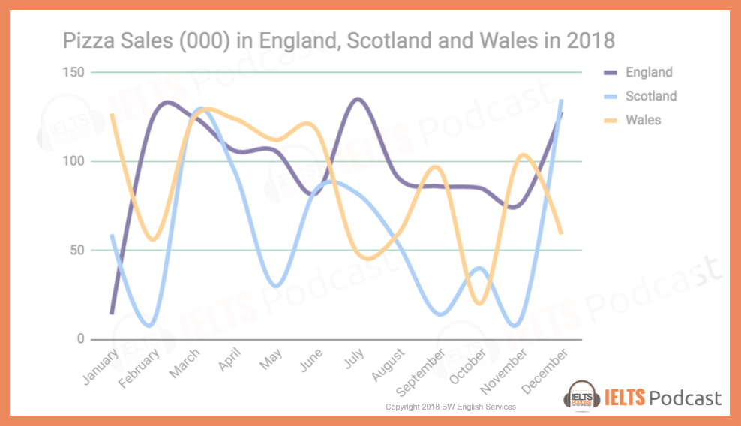

The given graph compares the amount of rainfall occurring in England, Scotland and Wales each month in 2018.

Overall, while the three regions had different amounts of rainfall each month, it rained a relatively similar amount throughout all the regions in July which recorded more than 100ml. The month when it rained most unevenly by region was the month of February when England had the highest record of rainfall at 120ml whereas Scotland had the lowest at 20ml.

By comparing months, the record of England shows that it had rainfall between 90 to 120ml in January to April and July to December, but the lowest at 70ml in May and June. In Scotland, more than 100ml of rain occurred in January, March, July, October and December and less than 50ml in February and April. In May, June, August, September and November, it recorded between 50 to 100ml. Lastly in Wales, it rained more than 100ml in May, June and November and less than 50ml in January, April, September and October. In February, March, June, August and December, it rained between 50 to 100ml. (181 words)

FEEDBACK

1. Overview is too detailed. It should give overriding main trend and sense that stands out most. It’s not supposed to give any number or data. It’s too far to detail. You can say, While each of the regions fluctuated considerably, all three had relatively similar amount in July. Done. That would have been an overview.
2. Then, paragraph 3, it’s too monotonous. You found a way to cover all this numbers and months by using these ranges but it was too much. It would’ve been effective if you had done it with once or twice with your answer, but your entire paragraph is structured like this. It becomes monotonous and there’s no range of languages because everything is identical. And it’s difficult for readers to understand what the trends are here. You said the highest was this and lowest was that, it’s really repetitive. You have to break it up little more and provide variety of your language even if that means sacrificing some of the information. You just don’t need to include every pieces of information. There are 36 months to analyse and you can’t possibly include them all. You have to vary up your language more and give fewer details here.

ESSAY 8

Task 1

2018 Global Sales of iOS devices vs. Android

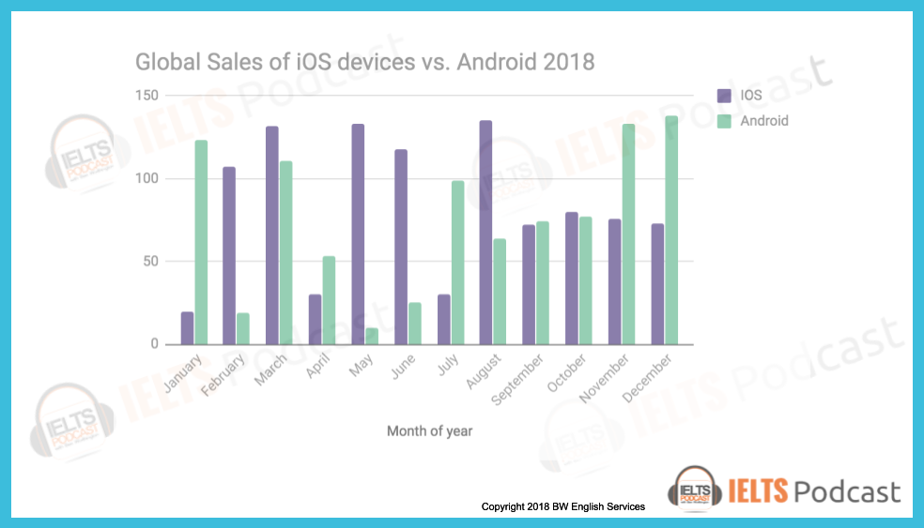

The given chart compares the monthly sales records of two major cell phone operators brands, iOS and Android, in the year 2018.

Overall, both Android and iOS recorded similar amounts of sales in September and October with a gap of less than five million. In both months, two companies recorded around 70 sales. The two companies recorded most drastically different amounts of sales in May with the gap of 100 million. iOS over sold Android with a sales record of 130 million whereas Android sold only 10 million cellphones.

By comparing between months, iOS sold more than 100 million cellphones in February, March, May June and August, and less than 50 million in January, April, and July. From September to December, their sales record remained between 50 to 100 million. Android sold more than 100 million cellphones in January, March, November and December and less than 50 million in February and May. In April, July, and from August to October, their sales record remained between 50 to 100 million. (171 words)

FEEDBACK

1. It’s not overview. Same as the previous one. Just focus on main trend and not much information on actual data.
2. You did exactly same type of writing. I don’t mind as much here because you only compare two different cellphone company but still it’s almost identical sentences.
3. New way: split it into half. You see iOS dominating the first half. You can say, for the first half of 2018, iOS dominated the market with more than 100 million sales in Feb, March, May, and June. In contrast, Android only reached this level in two months specifically in January and March. For the remainders of the first half of the year, sales for both companies were at or under 50 million. In second half of the year, iOS started out particularly low at around 30 million only to increase fourfold the following month. Following this period, it remained relatively stable around 30 million for the rest of the year. Android on the other hand, began the second half of the year at around 100 million then also have a period of stability around 30 million however it ended the year at the highest levels of the year in Nov and Dec at 130 million. -> change language, still use the range.

# ESSAY 9

**Task 2**

**Many people believe that it’s better to learn something in a group rather than individually. Do you agree or disagree?**

There are many ways to learn something and each person has a different preference whether to learn in a group or individually. Especially these days the importance of learning with one’s peer group has been illuminated as an effective way to learn easier and faster, and some say that it is even better than learning individually. I partially agree with this statement given that it truly depends on the type of subject that you want to learn.

The greatest benefit that one can get by learning in a group is that one have learning partners where you can get motivation, feedback, and knowledge. Setting a common goal and checking others’ status on achieving a learning goal can inspire you and help you keep up with what you are learning. This could fit well when you aim to learn something that you need others’ opinion or motivation on such as sports. You would need someone who can correct your position and stimulate you to not to give up

However, learning in a group also has a critical drawback by which it can rather degrade your motivation especially when you form a learning group with your close friends. Many people tend to think that they would enjoy learning more if they are with their close friends, but this can lead you to forget about your initial aim of study. When I was in my university, I gathered my close friends to study together on some common courses that we were taking, and most of them ended up not being as productive as we initially thought. More excuses came out as to why they could not participate in the group study each day and they began not prioritizing our study meetings in the daily schedule because they expected that the other members would understand as close friends.

Therefore, if you want to learn something that requires greater concentration and a well-organized scheme, individual study could yield better results in a shorter period. (325 words)

**FEEDBACK**

1. It’s fair enough. You can add one more sentence on second paragraph. Try to spend relatively equal amount of time to develop your paragraph. Do make sure that you cover both paragraphs relatively equal.
2. This was good. Grammar was fine just little errors this and there and don’t forget about the template as well.

# ESSAY 10

Task 1

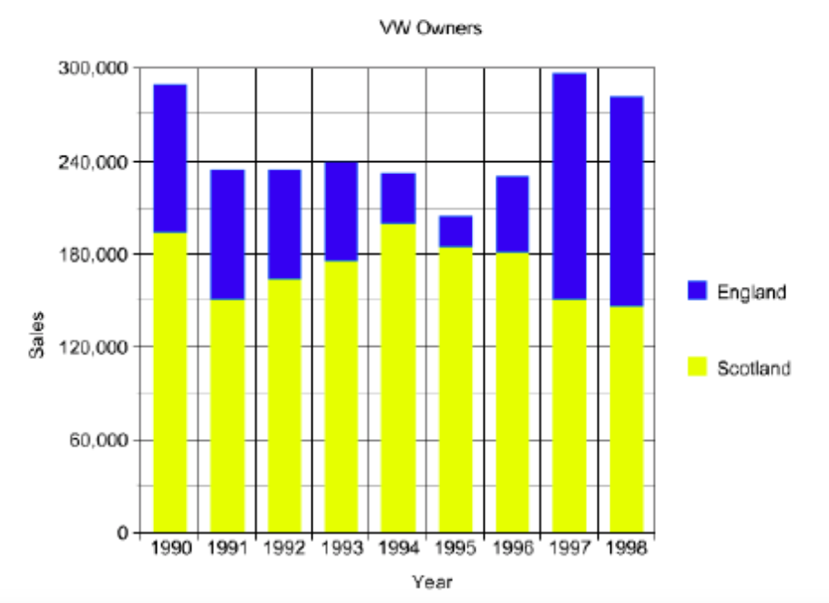

The given graph compares the number of VW owners in England and Scotland from 1990 to 1998. Overall, more sales were made in Scotland the England throughout the whole span of the chart.

In the first half of the 90’s, sales in Scotland dominated in all years from 1990 to 1994. It started with a huge gap between two regions by which the sales in Scotland were six times higher than England in 1990. Sales in Scotland dropped by 150,000 in 1991 and gradually increased again until 1994 when it recovered to be the same as in 1990, while sales in England started to decrease from 1990 and in 1994 only recorded one-third of the levels of 1990.

In the second half of the 90’s, sales in England reached their lowest at less than 30,000, and the total sales also reached the lowest in this year. Sales in England began drastically increasing from 1996 and reached their highest in 1997 which is five times more than its lowest in 1995. In Scotland on the other hand, it dropped under 150,000 in 1997 and 1998. Sales in England caught up with Scotland in 1997, and this trend remained until 1998. (196 words)

# Essay 11

## Task 2

**Nowadays some argue that democracy is under its biggest threat since inception, some argue that due to global capital markets the electorate has lost control of their government. What do you think? Give reasons and examples to support your position.**

As the world has been more connected than ever, global capital markets have expanded into very sophisticated forms and there has been more chance for capitalists to intervene one country’s democracy. I agree with this argument in a sense that the ones with economic power began performing more control in a government than those who do not have.

The first reason is that large corporations’ sales conditions are very dependent on economic laws that congress adjudicates. The range of conditions that corporations are in favor of varies from mere national tax regulation to international trade such as the export law of a country. The government is often keener to adjust their regulations to what corporations need rather than what individual electorates need as the sales of these corporations are also linked to national GDP.

Second reason is the corruption and collusion between government and corporations in order to create favorable conditions for large corporations. In 2016, there was a huge social movement in South Korea, on impeachment of previous president, Ms. Park, who was accused as receiving huge amounts of bribes from large corporations including Samsung and LG. As a consequence, Park was sentenced to go to prison for 16 years as well as the vice president of Samsung. As long as there is possibility of collusion between government and capital markets, government can hardly reflect individual electorate’s need.

Democracy has been threatened its fairness and equality of opportunities for a long time but now we have entered to a new phase that needs a solution from a different angle. Certain endeavor on dissolving the connection between government and global capital markets should be practiced as a priority. (280 words)

# Essay 12

Task 1

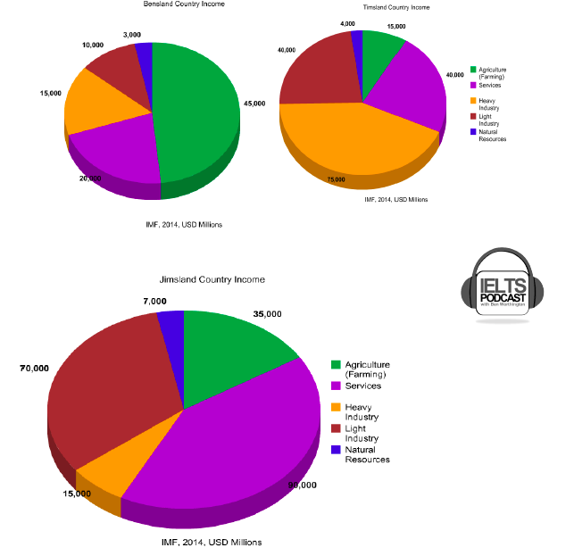

The given pie charts compare various income sources of three countries in 2014. Overall, Jimsland had biggest economic size followed by Timsland, and Bensland in terms of income amount.

While natural resources were the source which generated the lowest income in all regions, each country had strength in different sources. In Bensland, agricultural activities earned the highest income at $45,000 whereas heavy industry was the top source of income in Timsland and it was services in Jimsland at $75,000 and $90,000 respectively.

Comparing the four income sources with the exception of natural resources, agriculture in Timsland made only one-third of the levels of Bensland at $15,000 and $35,000 in Jimsland. Service generated less than a half of the income that Jimsland made at $40,000 and this was followed by Bensland where the income from service was another half of Timsland’s at $20,000. Heavy industry was a strong income source only in Timsland as the two other countries made only $15,000 each. Lastly, light industry yielded a little above than a half of Jimsland in Timsland at $40,000, and only a quarter of Timsland was made in Bensland at $10,000. (187 words)

**FEEDBACK**

* It’s actually US millions, not just US dollar.
* You have 15 pieces of information. Should you use all that information? Absolutely not. We need to wisely group together. You could’ve organized it by industry. Heavy and light industry together for each country, and then agriculture and natural resources together since they are from kind of similar source, and you can leave service by its own. You do have to group.
* Forexample, Heavy and light industries account for 15 and 10,000 in Bensland whereas this figure was far greater in Timsland at ~ and ~. While the figure from heavy industry in Jimsland and Bensland was the same in terms of dollar amount, it made up a smaller proportion of the income in Jimsland. You can say light industry was very large at 70,000 which is a little over a quarter of the total income.

Task 2

**Do you think it is better for students to work before their university study? Why? Share reasons and specific examples to support your choice.**

It is a common path for teenagers who recently graduated from their high schools to go straight into university. It seems like earning an undergraduate degree is more important than any other thing in their near future. I believe that having a certain amount of time before entering to university is essential in their life and having work experience would be one of the best ways to spend that gap.

One reason is that most of the high school teenagers cannot find their aptitude of studying. The subject that they choose for undergraduate studying could either fit them well or not, and they should ponder to choose the suitable one. Working as an intern or even as a part-time employee could help them navigate their areas of interest even if it is a short period. I was one of those who went to university straight away after high school, and I chose my major, Sociology, only because my test score fit into it and it is in the social science sector. I wish I could have known my areas of interest and what I would ultimately want to be. Having work experience in a related field would have helped me a lot to decide.

Another reason why students should work before university is that they can build interpersonal skills in work by dealing with many people from different backgrounds, and this could feed into their amicable social life once they get into university. Studying in university requires lots of teamwork and communication skills to deal with their professors. Those who already have the interpersonal experience is expected to yield higher scores in school tasks which involve teamwork and more qualified school life.

There have been more students who hold bachelor’s degree without a certainty of their future career or lack of interpersonal skills. Having a work experience before their university study would certainly benefit them in the long term. (321 words)

**FEEDBACK**

* There are a few areas that are incoherent, I really don’t know what you’re trying to say. It does creat some confusion.
* I want to see it more developed. 2nd boy paragraph is much shorter than 1st one. Same length of introduction. You really needed to explain it more.
* My counter argument is that, But in university also meet people from diverse background and you have to work together, so why does one need to work before university in order to gain this skill? This can’t be the uni inself provide and helps it develop? I’m little confused about this argument and I think there are other things that you could’ve said. For example, you can be more mature and responsible when you start working straightaway, rather than when you’re in a university setting with other pretty much same aged peers. When you’re working in an environment you have demands made from your boss and you really need to rise the challenge. So this is wonderful learning tool for students before getting into uni to really get a taste what awaits them after they finish university. Having this experience prior to university may help mold them and mold their decisions that they’ll make regarding their future.
* There are a number of word error.

# ESSAY

Task 1

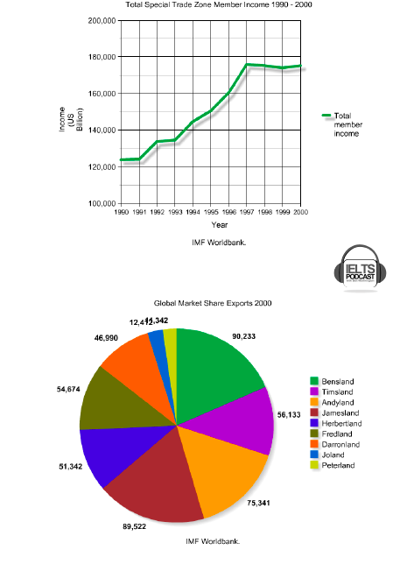

The given graphs show how special trade zone member income has changed from 1990 to 2000 and global market share exports in the year 2000. Overall, total income has gradually increased from 1990 to 1997 and remained relatively the same until 2000.

In 1990, total income started from around $125,000 billion and there was no increase by the following year of 1991. However, this amount began to surge since then, surpassing $140,000 billion in 1994 and reached its highest amount at $175,000 billion in 1997. It showed a little decrease from 1997 to 1999, but it recovered in 2000 to the same the level as that of 1997.

In the year 2000, Bensland, Timsland and Andyland each recorded more than $70,000 billion at $90,233, $89,522, and $75,341 billion, and this occupied more than a half of the total market share among the nine countries. This was followed by Timsland, Fredland, Herbertland and Darrenland which recorded between $30,000 to $60,000 billion. The remainders, Joland and Peterland had less than $13,000 billion. (170 words)

**FEEDBACK**

* This is not bad. I like the way you group together. That was smart way to do that. You can’t certainly talk all about it.
* Some of grammar mistakes but nothing too terrible.

Task 2

**Nowadays computer education is compulsory for young learners in most schools. Do you think this is necessary or will children acquire these skills naturally from their daily interaction with technology everywhere? Provide your opinion and use specific reasons and examples to support your answer.**

As technology has advanced, computer education has become more important than ever for children to prepare for the structural reform of the industries. I believe that computer skills that children deal with in their daily life remain at a basic level and this should be reinforced with compulsory computer courses.

First, the level of computer skills that industries require is far beyond the basic skills that people can learn easily without having a solid course. Most businesses run data in order to investigate consumers' need and preferences, and this involves a big-size data set and certain data programming. This cannot be acquired by daily interaction with technology and it needs to be taught by experts and solid guidelines so that children can be more used to dealing with data and programming.

Second, it is hardly expected to learn computer logic from daily life as technology has advanced, since most of the technological tools have become very user-friendly. For example, people are not even required to use their hands to turn on their electronics with the presence of artificial intelligence, since all they need to do is call it. Even though technology has become ubiquitous, it left from users' control and this gap will widen. Children should learn computer science in order to understand the logic and algorithms behind technology that cannot be acquired anymore by using it.

Learning computer science at an early age would be difficult, but it would be worthwhile in the long term. Schools should encourage more students to learn computer science and be well-prepared for the new industry.  (266 words)

# ESSAY

TASK1



The given graph compares the average band scores for Academic IETLS candidates in 2012. Overall, female candidates earned better scores than males in all four sections, and writing was the weakest section for both females and males.

For Listening and Reading, female candidates surpassed a band score of 6.0 at 6.1 each while males recorded 5.8 in both sections. The gap between females and males was widest in these two sections at 0.3.

Both females and males were weakest in the Writing section with their lowest score of 5.6 and 5.4 respectively and the gap between them was 0.2. The Speaking score average fell between the other three sections at 5.9 and 5.8 respectively, and both females and males had relatively even scores with the smallest gap of 0.1.

**FEEDBACK**

* It’s fine. Be careful with males and females.
* There are some awewardness. This was tough one because there’s no much difference but you did well and you talked about it. I’m wondering if it reached 150 words.
* It’s pretty good but little grammar mistakes.

**Task 2**

More governments in the world spend large amounts of money on art which helps to develop quality in people's lives. However, government should spend money on other thins rather than art. Do you agree or disagree? Give your opinion.

As cities have expanded, art has become very essential element of those cities to provide people a joyful environment .However, there are various problems that a country should focus on more such as income disparity and waste management. I think that government should listen to people's priorities on spending and allocate money to what they need rather than arts.

Firstly, government can enhance the quality of people's lives more by improving major problems that countries are facing rather than having art pieces. They can allocate funds spent on art to employment instead, for example, so that more people can get a job and be more satisfied with their lives. If the government spends more money on arts without solving the country's major problems first, the level of satisfaction that arts can give will degrade and become pointless.

Secondly, art pieces are judged very subjectively so it is hard to give the same level of pleasure to all people. For example, South Korean government made a huge golden sculpture of hand motions from the famous song Gangnam Style and put it in the heart of the city Gangnam a few years ago. Though it took a million dollars to make, there is a bigger portion of the South Korean publics who dislikes it. It is better for the government to spend money on certain issues that can satisfy more people.

There are many different ways that government can help to develop quality in people's life rather than arts. They should pay attention to people's desires and try to spend money on the right things.

**FEEDBACK**

* As a whole, I like this. I thought it was clear.
* The weekness of this essay was grammar, and additionally I would like to see this a little more developed. You said income disparity and waste management in introduction and you didn’t cover that. Don’t mention things that you’re not gonna develop. If you do have time to develop further, please do.
* I would have liked to see little more.
* But again, grammar is your top priority to concern.

Bonus Task 1

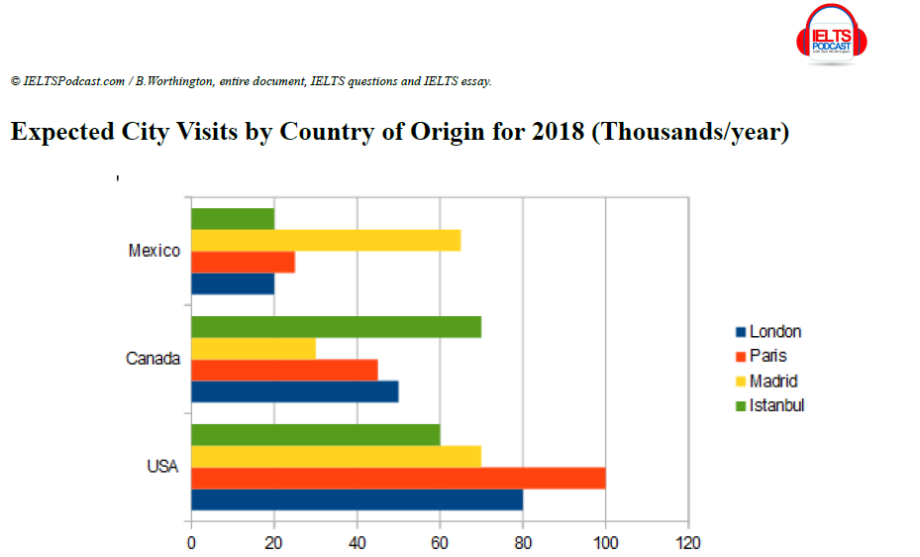

The given chart compares which city people expect to visit in 2018 by their country of origin. Overall, Americans are more willing to visit foreign cities than Canadians and Mexicans, and the distribution of expected cities varies by their country of origin.

London, Paris, and Madrid were the cities with the most expected American visitors 69,000, 100,000, 70,000 each. Istanbul had the most Canadians expected to visit at 70,000 people. London, Paris, and Istanbul expected the least Mexicans at around 20,000 people while Madrid was least popular in Canada.

In terms of their countries of origin, Mexicans chose Madrid as their city to visit at a little more than 60,000 people and both Istanbul and London were the least popular at 20,000 people. 70,000 Canadians chose Istanbul as their expected city to visit and only around a half of that chose Madrid at 30,000. Paris was the most popular city for Americans at 100,000 people and Istanbul was the least at 60,000.

FEEDBACK

* Just to see how you organized your paragraphs, I don’t totally understand.
* First, grammar was okay, your overview was okay, you have awkwardness in first paragraph.
* Your organizing is very confusing. You go from one country to one city, very confusing. I kind of understand why you did it like that, here you said the highest and lowest, but this particular chart lenses itself to that kind of organization.
* For me, it would’ve made a lot more sense in one of two ways. Could have spend a paragraph talking about America with the highest and lowest and kind of throw these two in between. You could’ve done the same thing for the other two. Mexico is really easy because Madrid is three times more than others. That could’ve been really quick paragraph, you could’ve just put it into one of other two.
* Alternatively, you could’ve spent a paragraph talking about the top in each country may be the least in the same paragraph and then you could’ve talked about middle score in second paragraph. But you should make sure that your organization is clear so that examiner can follow it. I think I know what you were trying to do but I don’t think that this chart is not a pretty good chart, that can’t lense itself to that kind of organization.